**Lab Report: 02**

**Title: Midpoint Algorithm**

*Course title: Computer Graphics Laboratory*

*Course code: CSE-304*

*3rd Year 1st Semester Examination 2022*

**Date of Submission**: 04/06/2023



**Submitted to-**

*Dr. Mohammad Shorif Uddin*

*Professor*

*Department of Computer Science and Engineering*

*Jahangirnagar University*

*&*

*Dr. Morium Akter*

*Associate Professor*

*Department of Computer Science and Engineering*

*Jahangirnagar University*

*Savar, Dhaka-1342*

| Class Roll | Registration Number | Name |
| --- | --- | --- |
| 346 | 20200650716 | Solaimi Hamid |

**Experiment Number: 01**

**Experiment Name: Midpoint Algorithm for a circle.**

**Source code:**

#include<bits/stdc++.h>

#include<graphics.h>

#include<dos.h>

#include<math.h>

using namespace std;

int main()

{

int xc,yc,x,y,r,gd=DETECT,gm,d;

cout<<"Enter radius of a circle: ";

cin>>r;

x=0;

y=r;

d=1-r;

initgraph(&gd,&gm,"");

cout<<"Enter the center coordinates of the circle: ";

cin>>xc>>yc;

do

{

putpixel(xc+x,yc+y,4);

putpixel(xc+x,yc-y,4);

putpixel(xc-x,yc+y,4);

putpixel(xc-x,yc-y,4);

putpixel(xc+y,yc+x,4);

putpixel(xc+y,yc-x,4);

putpixel(xc-y,yc+x,4);

putpixel(xc-y,yc-x,4);

if(d<0)

{

x=x+1;

y=y;

d=d+2*x+2;

}

else

{

x=x+1;

y=y-1;

d=d+2*(x-y)+1;

}}

while(x<y);

getch();

closegraph();

}

**Output:**

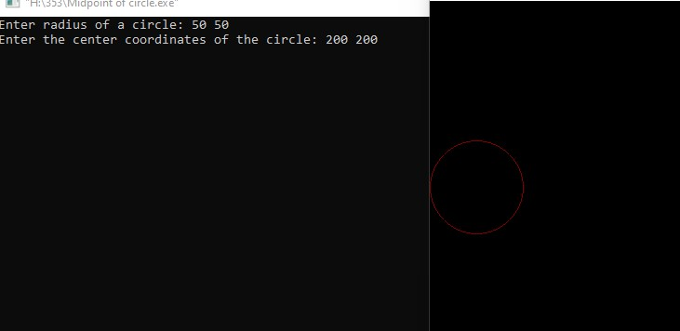

**Experiment Number: 02**

**Experiment Name: Midpoint Algorithm of a Ellipse.**

**Source code:**

#include<bits/stdc++.h>

#include <graphics.h>

using namespace std;

int main()

{

int gd = DETECT, gm;

initgraph(&gd, &gm, " ");

int xc, yc, rx, ry,x,y,Srx,Sry,TSrx,TSry,d;

cout << "Enter the coordinates of the center: ";

cin >> xc >> yc;

cout << "Enter the major radius & minor radius: ";

cin >> rx>> ry;

x=0;

y=ry;

Srx = rx * rx;

Sry = ry * ry;

TSrx = 2 * Srx;

TSry = 2 * Sry;

int px = 0;

int py = TSrx * y;

d = round(Sry - (Srx * ry) + (0.25 * Srx));

while (px < py)

{

putpixel(xc + x, yc + y, WHITE);

putpixel(xc - x, yc + y, WHITE);

putpixel(xc + x, yc - y, WHITE);

putpixel(xc - x, yc - y, WHITE);

x++;

px += TSry;

if (d < 0)

{

d += Sry + px;

}

else {

y--;

py -= TSrx;

d += Sry + px - py;

} }

d = round(Sry * (x + 0.5) * (x + 0.5) + Srx * (y - 1) * (y - 1) - Srx * Sry);

while (y >= 0)

{

putpixel(xc + x, yc + y, WHITE);

putpixel(xc - x, yc + y, WHITE);

putpixel(xc + x, yc - y, WHITE);

putpixel(xc - x, yc - y, WHITE);

y--;

py -= TSrx;

if (d > 0)

{

d += Srx - py; }

else

{

x++;

px += TSry;

d += Srx - py + px;

} }

getch();

closegraph();

return 0; }

**Output:**

